Guidance on Irrigation Control Using Mamdani-Style Type 1 Fuzzy Logic

**P2849288**

**BABU PALLAM**

MSc Artificial Intelligence

De Montfort University

02 May 2024

**Abstract**

**The recent technological advancements and strategies, such as IoT, Automation, and Artificial Intelligence, have accelerated the growth of farming industry with reduced human efforts, improved efficiency, and finally yield. Improved strategy or techniques for irrigation is one among several domains in farming which researched interestingly in search for. This report proposes a model which gives advice to irrigation system, which monitors real time weather statistics, such as humidity, temperature, and soil moisture, using sensors, and suggests how many litres of water should be used for irrigation in a square meter. With considering the related works in this field, a model has been proposed in this paper. Followed by that, the optimization of the model has been carried out and discussed the best FIS model found during the research. In addition to that several areas where need of further research have been discussed along with conclusion.**

**Keywords**

*Fuzzy Logic, Mamdani Type 1 FIS, Irrigation Control, MATLAB, Rule Base, Control Surface*

# 1. Introduction

At present, water conservation has become an important topic of discussion across the globe. Lack of rain fall and scarcity of water, the impact of irregular climate changes, and increase of population, have been influenced the researchers and technology enthusiasts to find new ways of conservation of water in different domains. In agriculture domain, the concern of conservation of water is not negligible. The demand of high food production makes the farmers more into increase the growth of production, but huge hike of water and electricity cost make it even harder for farmers to get successful in their field.

This report presents a solution for irrigation system using Type 1 Mamdani Model of FIS, a significant step for effective irrigation control system. The second section discusses about Literature review, in which the current state of the research happened in that area, and brief explanation of approach of the solution, the finally talks about a brief explanation of Mamdani Fuzzy Inference System(FIS) system. The section followed by this provides a detailed explanation about the implementation done which solves the stated problem. In the next section, optimization of the FIS system has been detailed by varying different parameters and techniques in various stages of the implementation. Followed by this section, section 5 discusses about the major challenges faced and observations. In section 6, a few areas where further research is important to improve the efficiency and reliability of the implemented system.

# 2. Literature Review

This section discusses about the related researched on solving the problem stated and the concepts and techniques used to solve this problem in this report.

## 2.1 Related Research

Decades of research and development of natural sciences and their technical applications have demonstrated several techniques for reduction of water usage in agriculture, by analysing various dependable factors including, pattern of the soil, land and geography, and the weather conditions.

#### Background

The introduction of Internet of Things (IoT) as part of industry 4.0 (Mohd Javaid, 2022), In which several were theory based without having a solid implementation strategy. An IoT based Smart Water Management System for irrigation (Kamienski, 2019) can be considered as the first project named SWAMP project which has successfully implemented over Europe. This project includes a well-defined strategy of five layered structure which aggregating the successful research outcomes including, sensors, drones, and weather forecasts to find a convenient advice to the farmers using a simple user interface application. The sensors to find moisture content of the soil, temperature, humidity make a significant impact in implementing real time analysis of data to find the instructions needed, however, the accuracy of prediction has always been a problem. The agricultural environment is always dynamic. Because the influencing factors such as weather conditions, the moisture level of the soil, etc. can always be varied. To solve this dynamic nature or can be referred to as uncertainty in the environment, to find the required solution, Fuzzy Interference System (FIS) can be a valuable tool. Several research works are available which discusses about some novel approaches with fuzzy logic and AI tools. Discussion of fuzzy logic in irrigation system (Khatri, 2018), and water irrigation system using IoT (Dhumale, 2023) are some of those. A brief description of Fuzzy logic has been given in 2.2.

This report focuses on SWAMP Project (Kamienski, 2019), where how can we improve it using Fuzzy Logic. The following subsection discusses the variables and the relationship between those.

#### 2.1.2 Modelling Problem

Giving advice to irrigation control system would be the primary aim of this report. So, three input variables are taken into consideration with one output from the FIS system.

##### 2.1.2.1 Input Variables:

1. **Soil Moisture:** Soil moisture is defined by the moisture content in the surface layer of the soil. It can be the amount of water as well as the amount of water vapor. The paper (Schmugge, 1980) talks about the over drying technique. At present, Tensiometers are being used to measure soil moisture tension, which was proposed by Cregg, (Cregg, 2017) which calculate soil moisture based on pressure, in bars.
2. **Humidity:** Humidity is the measure of water vapor content in the air, it can be said as moisture content in the air. In this implementation the absolute humidity has been considered to measure the humidity. It is measured in grams per cubic meter. For example, 10 grams of water vapor in 2 cubic meter means absolute humidity is 5grams/m3. In case of relative humidity, it calculated in percentage.
3. **Temperature:** The third input temperature is defined as the intensity of heat which contain in the air, which uses the scale degree Celsius, in this problem.

##### 2.1.2.2 Output Variable:

##### **1. Amount of Water:** It is measured in litres, in this problem the amount of water required per square meter is what we need to find.

##### 2.1.2.3 Relationship Between Input and Output Variables

###### Soil Moisture and Temperature

Based on the study by Yuan in 2019 in China (Yuan, 2019), decline of soil moisture happens during increase in temperature. Another study based on the results projected in the study done with the interaction between soil moisture and temperature at Mississippi ({Tang, 2017), the temperature effects negatively to the soil moisture irrespective of weather constraints like summer or winter. To summarize the three following conclusions can be drawn. 1. If Air Temperature is high, then it decreases the soil moisture level. 2. If soil moisture is high, it decreases the air temperature, 3. If soil moisture is dry, then temperature may or may not increase

###### Soil Moisture and Humidity

Based on the current research observed from papers, (Shangguan, 2016), (Torga, 2013), the following observation can be drawn which relates these two variables. 1. If soil moisture is high, then humidity can be high, 2. If soil moisture is moderate then humidity is high/moderate, and 3. If soil moisture is dry then humidity is low/moderate.

###### Temperature and Humidity

Warm air contain vacuum in between the air molecules. The warm air molecules move faster and farther apart, creating more space for water vapor molecules to fit in. So, If temperature is high and soil moisture is high then the humidity can be increased since evaporation rate will be increased.

## 2.2 Fuzzy Logic

This section discusses about the history of fuzzy logic, types and steps involved in fuzzy logic.

#### 2.2.1 History of fuzzy logic

Fuzzy logic was introduced by Lofti Zadeh in 1965, through his paper of concept of Fuzzy sets (Zadeh, 1965) which talks about the term fuzziness that implicitly improves the precision of any problem or statement. The decades of research in this area has extended this concept with several implementations and variants of fuzzy systems. The next section discusses about the common types of fuzzy systems.

#### 2.2.2 Types of fuzzy logic

The systems which uses fuzzy logic has been named as Fuzzy interference control systems. Which are widely used in different domains where decision making, and modelling is important. Depends upon the use-cases, different types of fuzzy control systems are being used.

Two popular control systems are Mamdani Fuzzy Logic (E.H. Mamdani, 1975), and Sugano Fuzzy Logic (Mehran, 2008). This report uses Type 1 Mamdani Fuzzy Inference System(FIS) for implementation of the modelled solution.

#### 2.2.3 Type 1 Mamdani FIS

It is one of the main FIS systems which handles uncertainty and imprecision with high flexibility. The main 6 steps involved are described below.

1. **Creating knowledge Base:** Formation of input and output parameters with the domain specification comes under this stage.
2. **Fuzzification:** Fuzzification is the process of creating fuzzy sets from the crisp sets with the help of Knowledge Base. With the help of membership functions, the inputs and outputs can be fuzzified with appropriate linguistic variables.
3. **Rule base:** The Rule Base consists of set of rules which says the connection between the input variables and output variables, based on linguistic variable of those.
4. **Rule Inference:** This step involves evaluation process of rules. Each of the given rule gets evaluated based on the MFs defined in the fuzzification process. This is done in two steps. First, apply fuzzy operator between the fuzzy sets, i.e. in between two MFs that denoted the input variable. Second, apply Mamdani Implication, which allows us to find the output fuzzy set based on the fuzzy input sets.
5. **Rule Aggregation:** Step followed by step 4. In this step, aggregation of all the outputs which has been received after the evaluation of each rule is performed. Three aggregation methods used in this model (MathWorks, 2024) are sum (sum of the rule output sets), probor (probabilistic OR), and max (maximum).
6. **Defuzzification:** The output we received in the previous step is in fuzzy, which cannot be an appropriate solution, so to make it into crisp solution, defuzzification process helps. Defuzzification does the conversion of the aggregated output into a number. Five known methods (LabView, 2024) used in this report are: 1. Centroid(Centre of Gravity), 2. Bisector(Centre of Area), 3. Middle of maximum(MoM), 4. Smallest of maximum(SoM), 5. Largest of maximum(LoM).

## 2.3 Tools and Terminologies Used in This Report

This section talks about the tools and terminologies used in this report.

#### 2.3.1 FIS designer toolbox of MATLAB

Among different toolsets available now to design, simulate and implement fuzzy logic concepts, with various languages and frameworks, this report used FIS Designer Toolbox (The MathWorks, Inc., © 1994-2024 ) which is comprised with MATLAB, which is a framework and a language developed by MathWorks. This toolbox allows us to implement and simulate the whole steps of FIS system which are mentioned in section 2.2.3.

#### 2.3.2 Membership functions (MF) in mathematics

Membership functions in mathematics are used in fuzzy logic to express the membership value of a variable in the fuzzy set. Various membership functions are available, and each is defined with a specific formula which has been proved already. The MFs used in this report has been provided in Appendix 1.

# 3. Implementation of FIS

The implementation of FIS system followed the steps mentioned in the above section. Each subsection this follows the flow of the steps in building the proposed FIS system. Note that the data and techniques used in this are for initial implementation, the optimization will be carried out later over this implementation done. The implementation details are as follows.

##### Knowledge base

Based on the input and output variables defined in modelling the problem (see 2.1.2), the parameter and domain specification has been given in the table 1. As can be seen, in Table 1, three linguistic variables have been defined for each input and output variable.

|  |  |  |  |
| --- | --- | --- | --- |
| **TABLE 1: Knowledge Base** | | | |
|  | **Name** | **Linguistic Variable Name** | **Remarks** |
| **I**  **N**  **P**  **U**  **T**  **S** | Soil Moisture (0 - 800 bars) | WET | Moisture is high |
| MODERATE | Moisture is average |
| DRY | Low moisture |
| Humidity  (0 - 60 g/m3) | LOW | Low Humidity |
| MODERATE | Average humidity |
| HIGH | High Humidity |
| Temperature (0 to 50 degree Celsius) | LOW | Low Temparature |
| MODERATE | Average Temperature |
| HIGH | High Temperature |
| **O**  **U**  **T**  **P**  **U**  **T** | Irrigation (l0 - 50 litres/m2) | LOW | Amount of water needed is low |
| MODERATE | Amount of water needed is avg. |
| HIGH | Amount of water needed is high |

Next step to be carried out is fuzzification, which this section follows.

##### Fuzzification

This process does the conversion of crisp set to fuzzy set. In which each linguistic variable is represented using one of the membership functions. The fuzzification table (See Appendix 2.1) provides the details of the parameter range of each linguistic variable and the membership function assigned for the initial implementation (See Appendix 2.3).

##### Rule Base

The step followed by the fuzzification is creating rules which depicts the relationship between the input and output variables. The table 2 given below provides

|  |  |  |  |  |
| --- | --- | --- | --- | --- |
| **#** | **TABLE2: RULE BASE** | | | **OUTPUT** |
|  | **Soil Moisture** | **Humidity** | **Temperature** | **Irrigation** |
| 1 | DRY | LOW |  | HIGH |
| 2 | DRY | MODERATE | MODERATE | MODERATE |
| 3 | DRY | MODERATE | HIGH | HIGH |
| 4 | DRY | HIGH | ~MODERATE | MODERATE |
| 5 | MODERATE | LOW | LOW | MODERATE |
| 6 | MODERATE | ~HIGH | HIGH | HIGH |
| 7 | MODERATE | ~HIGH | MODERATE | MODERATE |
| 8 | MODERATE | MODERATE | LOW | LOW |
| 9 | MODERATE | HIGH | ~HIGH | LOW |
| 10 | WET | LOW | ~HIGH | LOW |
| 11 | WET | LOW | HIGH | MODERATE |
| 12 | WET | ~LOW |  | LOW |

the rules defined as part of implementation. The description of the rules and how the rules have been formed have been defined clearly (See Appendix 2.2). Rule base has significant role in the next step, called Rule Inference process.

##### Rule Inference

As discussed in section 2.2.3, the consequences of the rules are determined at this step. This implementation was based on Min T-NORM (fuzzy operator), Mamdani minimum (implication operator) and sum (aggregation operator) . The result obtained (See Appendix 2.4) of each of the twelve rules have been observed and ensured that the rules have covered the whole range of input and output domain range and no contradiction and no replication among the rules.

##### Rule Aggregation

This step relates to the previous step, Rule Inference, but it was purposeful to separate it from that step, to do a better performance analysis in the coming section. This implementation used sum of rule outcomes as aggregation method (See Appendix 2.4).

##### Defuzzification

The result of defuzzification in this implementation is the amount of water needed for irrigation for a square meter (See Appendix 2.4). The result obtained after the whole process is illustrated using surf feature of MATLAB (See Appendix 2.5). Some arbitrary results have been pointed in the graph which shows the correctness of the FIS system implemented.

The next section, section 4, further investigates by carrying out several tests, to optimize the model implemented with respect to different techniques and approaches by replacing the once which has been deployed already.

# 4. Optimisation of FIS

### 4.1 Effect of Membership Function

To see the effect of membership functions in the FIS system, the FIS system has been reimplemented with Triangular MF, Trapezoidal MF, Gaussian MF, and Generalized Bell MF. The smoothness of the control surface has been examined after the tuning of the domain values and boundaries of linguistic variables of each input variable (See Appendix 3.1). The following observations have been drawn.

* When the membership function boundaries are limited to the input variables boundary, the edges of the graph were not refined and showed abnormal behaviour (See test results provided in 1.1, 2.1, and 3.1 of Appendix 3.1)
* When boundaries (min and max values ) of MF’s are relaxed beyond the input range, then the smoothness of the curve, which says the transition or smooth dilution of linguistic terms of an input variable, observed (See test results provided in 1.2, 2.2, 3.2, and 4.2 of Appendix 3.1).

The FIS systems implemented with different membership functions have been tested for 31 input combinations (See Appendix 4.1). While comparing with the logic of the rules created and the output received along with the control surface resulted with each graph, three observations found.

1. The surf plot resulted with gaussian MF, gives a smooth curve, over the others which shows clear edges or several level offs during the transition from one linguistic variable to another.
2. But for several inputs, one made used Trapezoidal graph shows more performance result compared to gaussian or generalized bell MFs. For example, see input (800, 60, 30), that is soil moisture is wet, humidity is maximum, and temperature is average, in this case the amount of water irrigation needed is least, and the least result found is 12.3 which is the FIS system implemented with Trapezoidal MF. But, during the level off, or the flat surface on the control surface, the resulted output found to be same, for more than one input combinations, this can not be listed as a fair from the perspective of an efficient and improved model.
3. The combination of the MFs applied and the result found was not optimum since the clear edges were visible in the control surface.

Having stated above, the observation 2 cannot be considered and ignored with necessary consideration but to conclude, FIS system with Gaussian MF is noticed as the optimum FIS among the test result received.

### 4.2 Effect of Rules

The rules defined in the FIS system has a major impact in the rule inference and can be seen in the visual result the surf provides. The smoothness of the curve in control surface shows the contradicting rules exist and absence of the linguistic variables used or defined. It is observed that according to the problem logic, the number of rules can be varied. When the rule weight change to 0, the rule becomes invalid, which effects the result. The rule weight gives preference to the rules and the complexity increases as it changed and connected with multiple rules.

### 4.3 Effect of Operators

Effect of operators is important to note especially during the rule interference, rule aggregation, and defuzzification process. The observations found has been summarized below.

###### Fuzzy operator

Tests carried out changing TNORM and TCONORM operators for each rule among 12 rules defined and observed the effects on the control surface (See Appendix 3.2).

With TCORM, while comparing the result obtained, (which are marked in the figures), for each operator, such as min, and prod, ‘prod’ function was found to be more promising in terms of producing the right result (See Appendix 3.2, Ob1 and Ob2), since the values found while using “centroid” as the defuzzification method are most close towards the domain boundary of the output.

With TCONORM, while comparing the result of each operator, such as max, probor, sum, the result was completely away from the required result (see Appendix 3.2 Ob3, Ob4, and Ob5). Since TCONORM and TNORM are compliment to each other ( min and max operators), complimenting the variables state can solve the problem when apply TCONORM max. To conclude, the rules must be redefined to use TCONORM operators.

###### Implication operator

MATLAB provides min (Mamdani implication) and prod (Larsen’s product) as operators to find the consequences of each rule, which connects the input variables with output variable(s). While comparing the graph obtained after tests (See Appendix 3.2 Ob06 and Ob07), both gives similar result, but ‘prod’ found to be more improved one since the edges are more towards the boundary values.

###### Aggregation operator

Three aggregation operators such as, max, probability OR, and sum, tested with the FIS system, and ‘sum’ has been selected as the best while comparing with other two. The reason to differentiate it from the among is the smoothness of the curve especially while observing the edges of the graph.

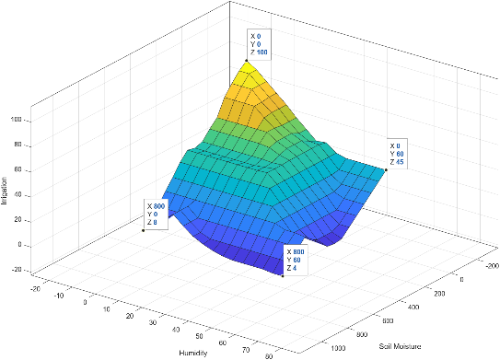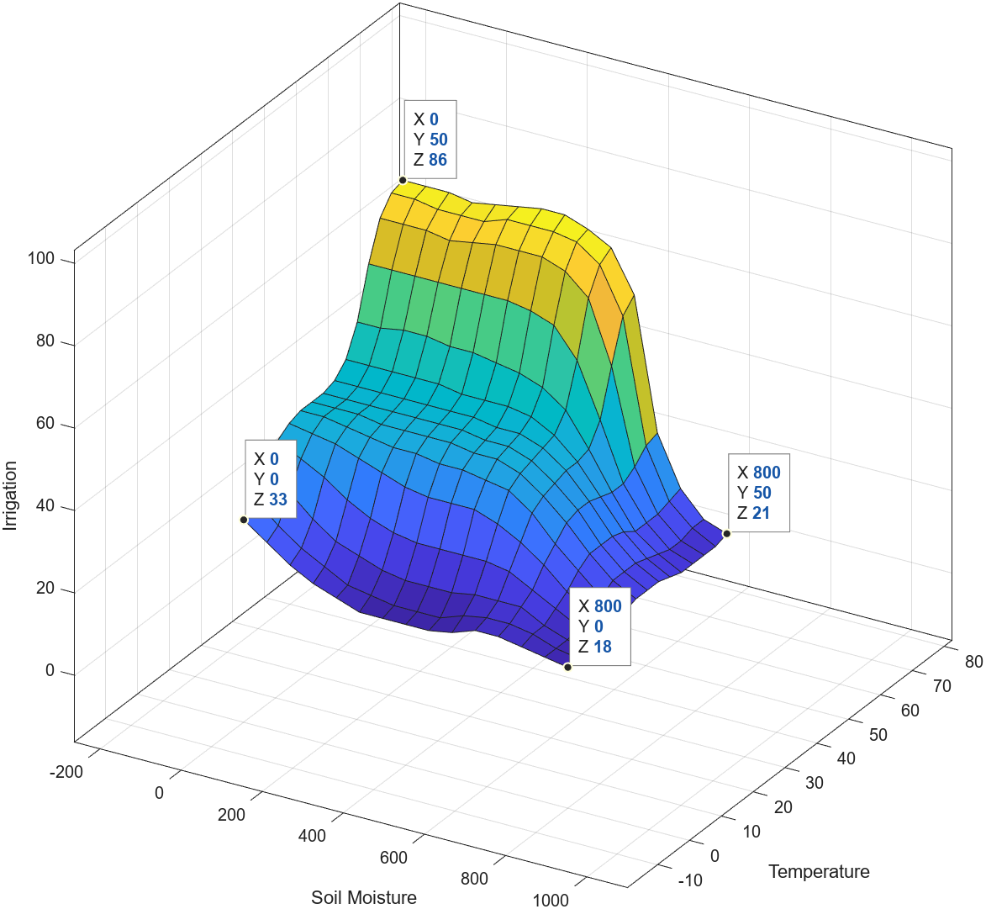

Figure 1

###### Defuzzification operator

Compared to other operators analysed, this operator has been seen as most significant one, since this operator does the reshaping of the fuzzy output into a number. So, accuracy of the result is reflected as this operator changes. While comparing with several test inputs against the rule inference with each fuzzification operator, ‘som’ – smallest of Maximum has been chosen as the best for the selected problem (See Appendix 3.2 Ob14) because of the following observations.

* ‘centroid’, and ‘bisector’ provides graph which is smooth and refined without any visible edges or unintended spikes (See Appendix 3.2 Ob11 and Ob12). According to the problem defined this has been seen as not appreciable. Since the output doesn’t come to the boundary defined.

|  |  |
| --- | --- |
| Membership Function | GAUSSIAN MF |
| Fuzzification operator | PROD (AND) |
| Implication Operator | MIN |
| Aggregation Operator | SUM |
| Defuzzification Operator | SOM |

* ‘mom’ and ‘lom’ are also good compared to ‘centroid’ and ‘bisector’, (See Appendix 3.2 Ob13 and Ob15) but variation can be seen in one place on each control surface which has been considered as not fair while testing with several inputs while comparing with ‘som’.

# 5. Discussions

This section provides a brief discussion of the best model obtained after the optimization of FIS proposed along with a few challenged faced during optimization.

## 5.1 Optimized FIS and Outline of Specification

The optimization carried out with parameter tuning and various techniques drawn an observation that the best solution with respect to the problem defined can have multiple perspectives. The control surfaces (See in Figure 1) shows how the rules are defined. The test have been performed with this FIS system against more than 30 inputs (See last column of Table in Appendix 4.1) and the result has been analysed based on the rules and logic of this FIS defined (See Appendix 4.2); the result was impressive. The outline of the process specification has been provided in the table below.

See Appendix 4.2, for the details of FIS, including the MATLAB code of the implementation which resulted the Figure 1. See Appendix 4.2 for the explanation of the accuracy of the prediction. Among 32 tests carried out, the logical explanation for the output received of 3 input combinations couldn’t find (See rows 6,13, and 19 in the Table given in Appendix 4.2). Considering these 3 are errors among 32 test outcomes, the accuracy of the FIS system can be calculated as given below.

$$AccuracyofFIS\left(\%\right)=\left(\left(32-3\right)/32\right)*100$$

$$= 90.625$$

The accuracy of FIS wad found to be 90.625, which can be considered as fair result though the testing was not come as the result of real data.

## 5.2 Challenges faced during the Optimization Process

Two challenges faced during this research. First one was challenges in acquiring testing data. The data set used here to ensure the correctness of the model is created theoretically based on the logic and relationship of variables associated with the problem. So sourcing original data or collecting real time data from the sensors to train the model created found to be important, which can be considered as for further research.

Second challenge noticed is finding combinations for the perfect FIS without making inferences, which would be most likely try and error, so a few theoretical assumptions had to be made as part of finding consensus for the best solution. The requirement of a handful of tests using a continuous period is found to be considerate prior to real world implementation.

# 6. Further Research

In addition to the challenges discussed in 5.2, some of the recommendations to extend this research has been given below.

* **Limitations in normalisation of data:** Different standards and techniques exist in the world to measure the input and output variables of the proposed model so, the accurate normalization of data prior to the use needs attention. Thereby, further research is required.
* **Limited MFs:** To assign membership of each input in fuzzy system, this research has compromised with the use of pre-exist MF like triangular, gaussian, etc. The importance of defining the MF according to the input and output variables domain and characteristics found to be a point where need of further research is mandatory, like how fuzzy logic can be involved in designing systems which is build using concept of neural network.
* **Different Fuzzy Approaches:**  There are different proven fuzzy control models are available other than Mamdani Type 1 Model, such as Mamdani Type 2 (Hagras, 2007), Takagi-Sugeno Type 1, etc. So extensive research via modelling the FIS system using different approaches and comparing the models to see which one is the best in terms of accuracy and performance is important.

# 7. Conclusion

This report presented a model with a systematic and efficient irrigation plan for farmers using Mamdani Type 1 Fussy Inference system (FIS) with the integration of IoT, which includes the collection of real time sensor data. The literature review of the current research in this field and the concepts and terminologies used for modelling this problem has been discussed at the beginning. Further, the implementation of the model has been discussed. Later, the optimization of the implemented FIS has been carried out with different tests by applying different operators and techniques on each stage of the FIS modelling, including fuzzification, rule inference, and defuzzification. Followed by this, a discussion has been included about the optimized FIS along with discussing some challenges faced during the optimization process. Finally, three areas have been stated where the need of further research was found along with conclusion.

# References

Cregg, 2017. *Irrigation Management Mesuring Soil Moisture.* [Online]   
Available at: https://www.canr.msu.edu/news/irrigation_management_measuring_soil_moisture_and_application_uniformity

Dhumale, R. a. D. N. a. U. A. a. N. S. a. M. P. a. S. A., 2023. Fuzzy Internet of Things-based water irrigation system. *Agricultural Engineering International: CIGR Journal,* Volume 25, p. 2.

E.H. Mamdani, S. A., 1975. An experiment in linguistic synthesis with a fuzzy logic controller. *International Journal of Man-Machine Studies,* Volume Volume 7, Issue 1,, pp. Pages 1-13.

Kamienski, C. a. S. J.-P. a. T. M. a. D. R. a. T. A. a. S. C. T. a. F. M. R. a. T. N. A., 2019. Smart water management platform: IoT-based precision irrigation for agriculture. *Sensors,* 19(MDPI - https://doi.org/10.3390/s19020276), p. 276.

Khatri, V., 2018. Application of Fuzzy logic in water irrigation system. *Int. Res. J. Eng. Technol,* 5(4), p. 3372.

Mehran, K., 2008. akagi-sugeno fuzzy modeling for process control. *Industrial Automation, Robotics and Artificial Intelligence (EEE8005),* 262(Newcastle University Newcastle upon Tyne, UK), pp. 1-31.

Mohd Javaid, A. H. R. P. S. R. S. E. S. G., 2022. Understanding the adoption of Industry 4.0 technologies in improving environmental sustainability,. *Science Direct,* Volume 3(ISSN 2666-4127, https://doi.org/10.1016/j.susoc.2022.01.008. (https://www.sciencedirect.com/science/article/pii/S2666412722000071)), pp. Pages 203-217,.

Schmugge, T. a. J. T. a. M. H., 1980. Survey of methods for soil moisture determination. *Water Resources Research,* 16(6), pp. 961-979.

The MathWorks, Inc., © 1994-2024 . *FIS ToolBox.* [Online]   
Available at: https://in.mathworks.com/products/fuzzy-logic.html  
[Accessed 24 04 2024].

Zadeh, L. A., 1965. Fuzzy set. *Information and control,* 8(Elsevier), pp. 338-353.

## **APPENDIX 1:** Membership functions in Mathematics of Fuzzy Logic

|  |  |  |  |  |
| --- | --- | --- | --- | --- |
| # | **Membership Function (MF) Name** | **Definition** | **Associated Graph** | **MATLAB Function Name** |
| 1 | Triangular (TRIM) MF (Mocq, 2006) |  |  | Syntax: y = trimf(x, params)  Ex.: y = trimf(x, [4 10 15]); |
| 2 | Trapezoidal (TRAP) MF (Hossain, 2018) |  |  | Syntax: y = trapmf(x,params)  Ex.: y = trapmf(x,[0 4 8 10]); |
| 3 | generalized bell-shaped (GBELL) MF (MathWorks, 2024) |  |  | Syntax: y = gbellmf(x, params)  Ex.: y = gbellmf (x, [4 10 15]); |
| 4 | Gaussian(GAUSS) MF (MathWorks, 2024) |  | Gaussian membership function: G(x;s,c). | Download Scientific Diagram | Syntax: y = gaussmf(x, params)  Ex.: y = gaussmf(x, [1 0]); |
| 5 | Sigmoidal (SIG) MF (MathWorks, 2024) |  |  | Syntax: y = sigmf(x, params)  Ex.: y = sigmf(x, [2 4]); |

## **APPENDIX 2:**

### 2.1: Fuzzification Table

|  |  |  |  |  |
| --- | --- | --- | --- | --- |
| **Fuzzification Table** | | | | |
|  | **Name** | **Linguistic Variable Name** | **Range with Domain** | **MF**  **Used** |
| **I**  **N**  **P**  **U**  **T**  **S** | Soil Moisture (0 - 800 bars) | WET | [0 0 98.23 340.1] | Trapezoidal |
| MODERATE | [211.257 341.6 556.168] | Triangular |
| DRY | [417.1 682.9 800 800] | Trapezoidal |
| Humidity  (0 - 60 g/m3) | LOW | [0 0 8.634 23.5203] | Trapezoidal |
| MODERATE | [14.7136 29.88 45.9308] | Triangular |
| HIGH | [36.1217 51.98 60 60] | Trapezoidal |
| Temperature (0 to 50 degree Celsius) | LOW | [0 0 11.44 22.69] | Trapezoidal |
| MODERATE | [15.1721 25.1812 35.6431] | Triangular |
| HIGH | [24.7736 44.9728 50 50] | Trapezoidal |
| **O**  **U**  **T**  **P**  **U**  **T** | Amount of Water (0-100 litres/m2) | LOW | [0 0 13.02 40.0599] | Trapezoidal |
| MODERATE | [25.2096 50 76.1503] | Triangular |
| HIGH | [60.7784 85.2 100 100] | Trapezoidal |

### 2.2: Rule Base

|  |  |  |  |  |  |
| --- | --- | --- | --- | --- | --- |
| **RULE BASE** | | | | | |
| **#** | **INPUTS** | | | **OUTPUT** | **Remarks/Reason** |
|  | **Soil Moisture** | **Humidity** | **Temperature** | **Irrigation** |  |
| 1 | DRY | LOW |  | HIGH | Plant need water to compensate and low humidity increases evaporation |
| 2 | DRY | MODERATE | MODERATE | MODERATE | Moderate irrigation needed since humidity is moderate, evaporation would be less because of moderate temperature |
| 3 | DRY | MODERATE | HIGH | HIGH | Same as rule 2, but since temperature is high, irrigation should be high, as evaporation rate is high. |
| 4 | DRY | HIGH | ~MODERATE | MODERATE | Low evaporation because of high humidity. So moderate irrigation would be needed. |
| 5 | MODERATE | LOW | LOW | MODERATE | Since temperature is low, evaporation would be low, so moderate irrigation is enough to maintain wetness of soil. |
| 6 | MODERATE | ~HIGH | HIGH | HIGH | High temperature and low or moderate humidity cause evaporation, so high irrigation is needed to maintain the optimum water level of soil. |
| 7 | MODERATE | ~HIGH | MODERATE | MODERATE | Like rule 5, but since the temperature is moderate, evaporation would be moderate, so moderate irrigation is enough. |
| 8 | MODERATE | MODERATE | LOW | LOW | Temperature is low and humidity is moderate, so low irrigation is enough to maintain the soil moisture since the soil is moderately wet. |
| 9 | MODERATE | HIGH | ~HIGH | LOW | High moisture and moderate or low temperature will maintain the moisture content in the air, so low irrigation is enough to maintain the wetness of soil. |
| 10 | WET | LOW | ~HIGH | LOW | Soil is already wet, and the temperature is moderate, so evaporation rate would be less though the humidity is low, thereby low irrigation is enough. |
| 11 | WET | LOW | HIGH | MODERATE | Soil is wet, but temperature is high, and humidity is low, so significant evaporation would happen, so irrigation must be moderate to maintain the optimum water level in the soil. |
| 12 | WET | ~LOW |  | LOW | Soil is wet, and humidity is now low, which means that irrespective of temperature the evaporation rate is less, so low irrigation would suffice the problem. |

### 2.3: Fuzzification Results

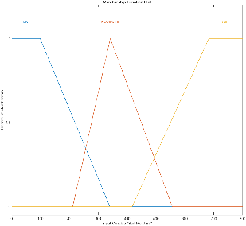

Fig 1 Soil Moisture

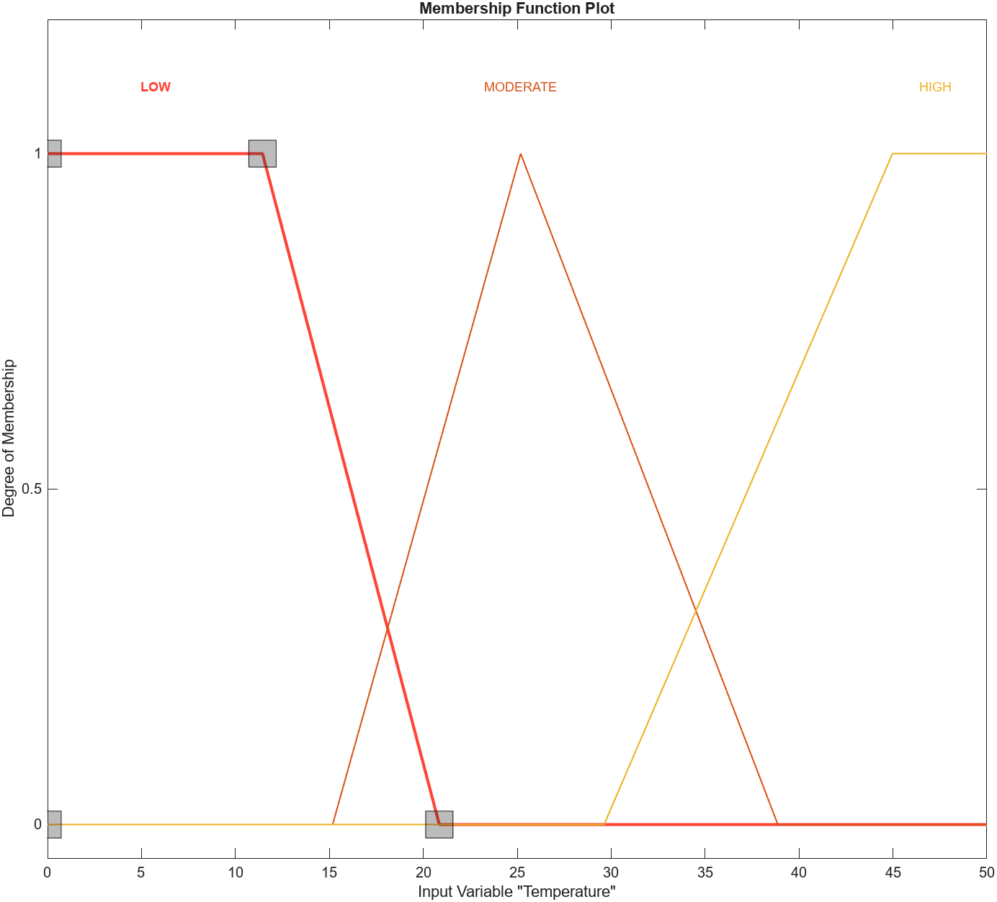

Fig 1 Temperature

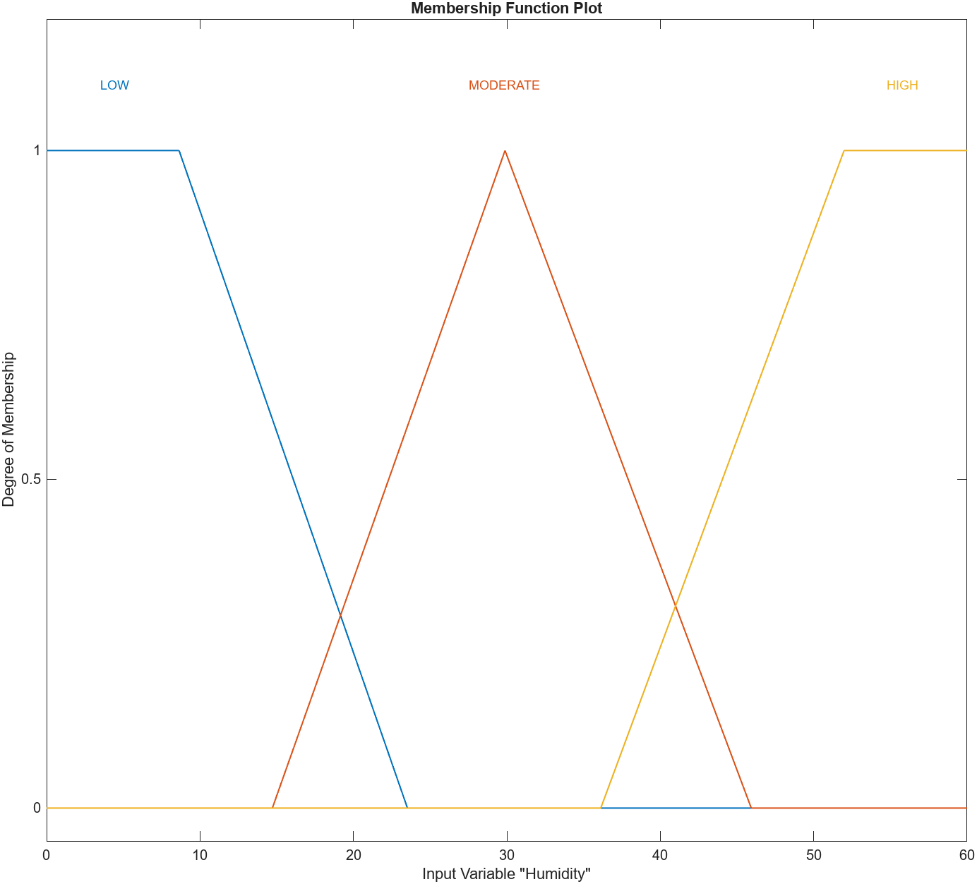

Fig 1 Humidity

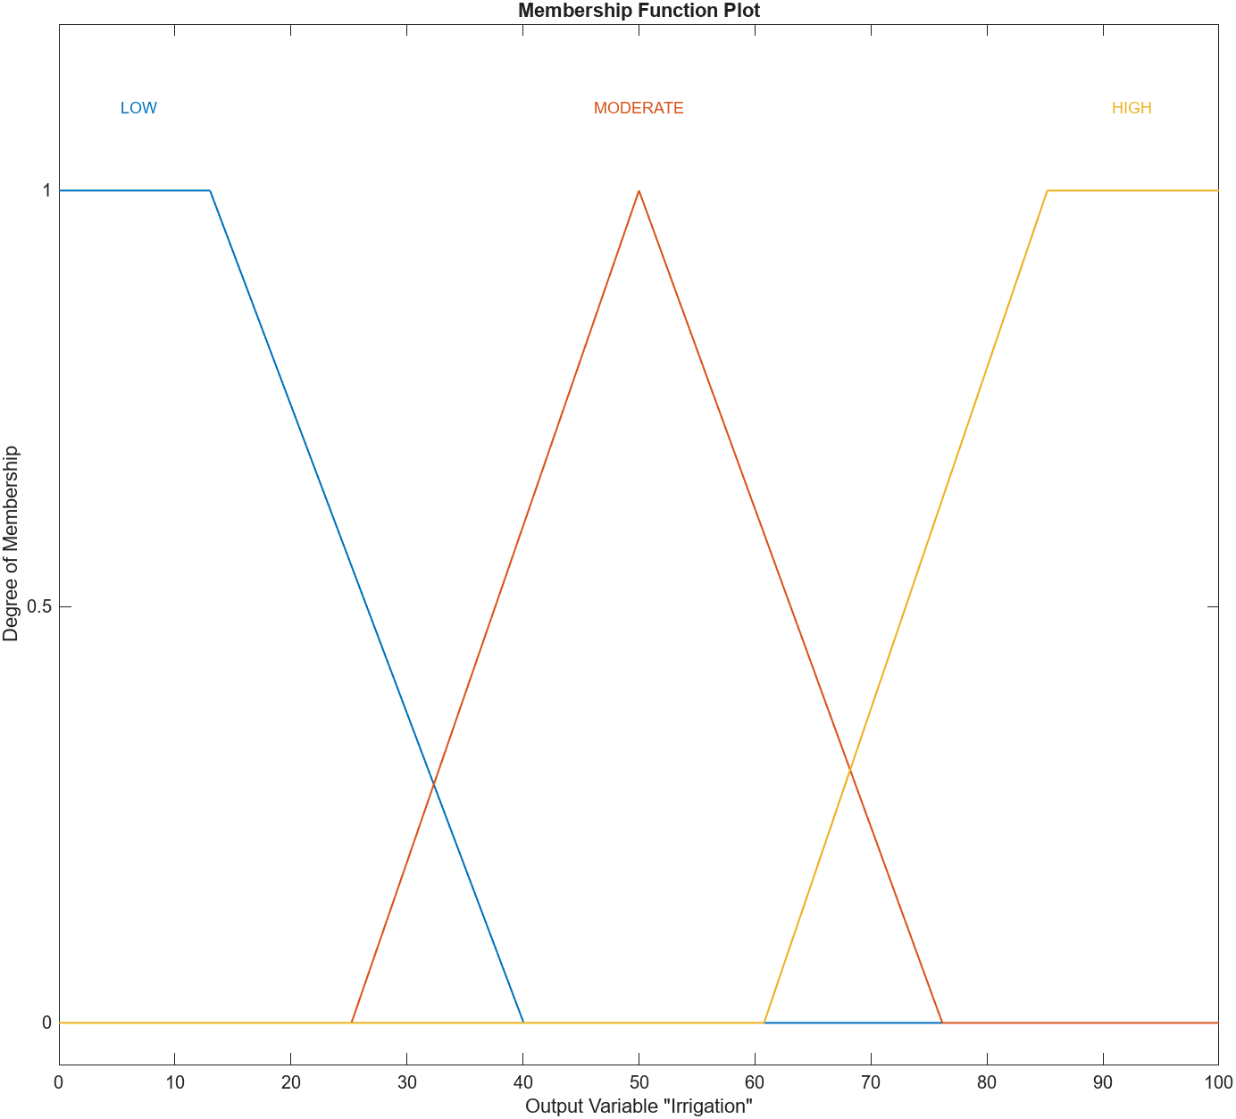

Fig 1 Irrigation

**INPUTS**

**OUTPUT**

### 2.4: Rule inference

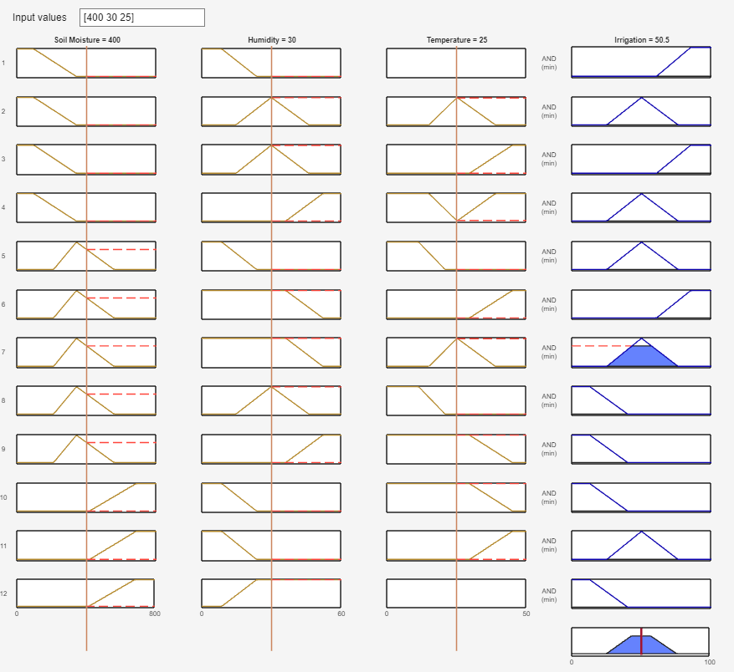

RULE AGGREGATION RESULT

## 2.5 Results with Control Surface (Surf based Graphs)

Soil Moisture and Temperature Effect in Irrigation output

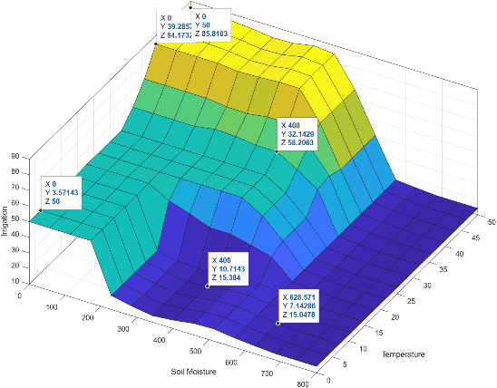

Soil Moisture and Humidity Effect in Irrigation output

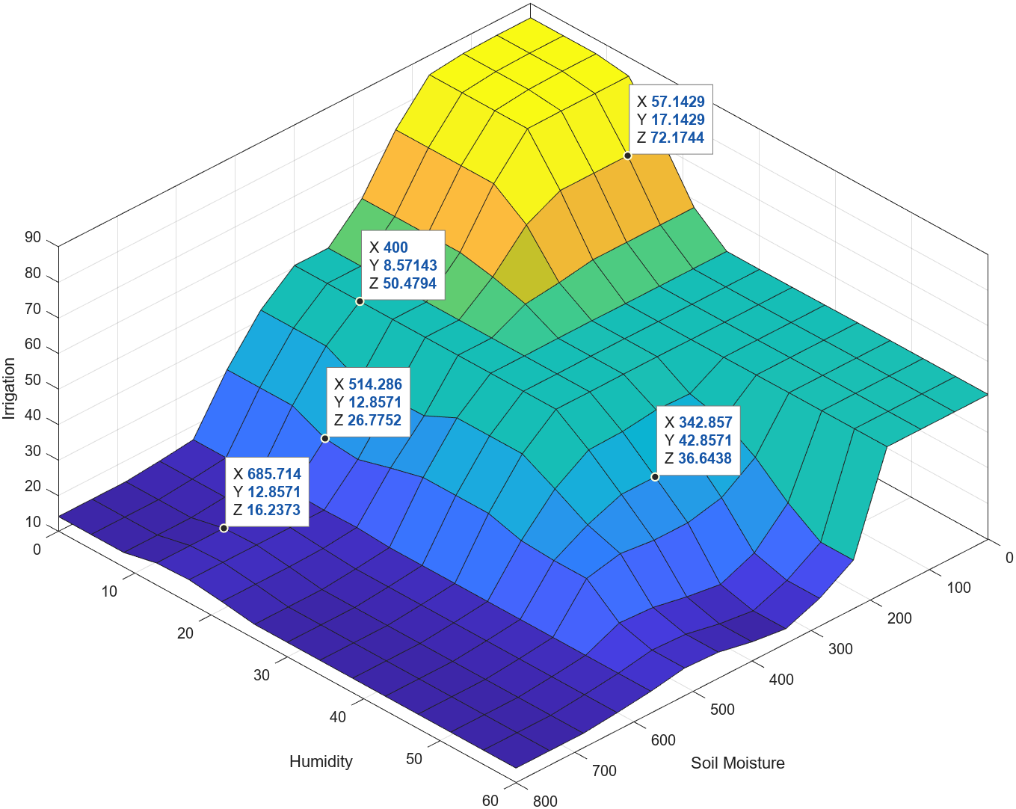

## **APPENDIX 3:**

### 3.1 Effect of Membership Function

|  |  |  |  |  |
| --- | --- | --- | --- | --- |
| # | **Membership Function (MF) Name** | **Control Surf:**  **Soil Moisture and**  **Temperature** | **Control Surf:**  **Soil Moisture and**  **Humidity** | **Remarks** |
| 1.1 | Triangular (TRIM) MF |  |  | A diagram of a type of soil moisture  Description automatically generated  IBSBM3.1_1 |
| 1.2 | **Triangular (TRIM) MF (Optimized)** |  |  | A diagram of different types of soil moisture  Description automatically generated  IBSBM3.1_2 |
| 2.1 | Trapezoidal (TRAP)MF |  |  | A diagram of a diagram  Description automatically generated  IBSBM3.1_3 |
| 2.2 | **Trapezoidal (TRAP)MF (Optimized)** |  |  | A diagram of a type of soil moisture  Description automatically generated  IBSBM3.1_4 |
| 3.1 | Gaussian(GAUSS) MF |  |  | A diagram of different types of soil moisture  Description automatically generated  IBSBM3.1_5 |
| 3.2 | **Gaussian(GAUSS) MF (Optimized)** |  |  | A diagram of a diagram  Description automatically generatedIBSBM3.1_6 |
| 4.2 | **Generalized Bell MF (optimized)** |  |  |  |

## 3.2 Effect of Operators

## 

|  |  |  |  |  |  |
| --- | --- | --- | --- | --- | --- |
| **ANALYSIS OF FUZZY OPERATORS** | | | | | |
| **#** | **OPERATORS** | **METHOD ASSOCIATED WITH MATLAB** | **Based on Optimized FIS (3.2 in Appendix 3.1)** | **Remarks/**  **Conclusions** |  |
| Ob01 | AND (TNORM) | min |  |  |  |
| Ob02 | prod |  | The output values are closer to the boundary values. |  |
| Ob03 | OR (TCONORM) | max |  | Rules must be redefined. |  |
| Ob04 | prob or |  | Rules must be redefined. |  |
| Ob05 | sum |  | Rules must be redefined. |  |
| **ANALYSIS OF IMPLICATION OPERATORS** | | | | | |
| Ob06 | Mamdani’s  implication | min |  |  |  |
| Ob07 | Larsen’s  product | prod |  | Slight change observed in the graph. The values found is more promising that using min operator. |  |
| **ANALYSIS OF AGGREGATION OPERATOR** | | | | | |
| Ob08 | OR (TCONORM) | max |  |  |  |
| Ob09 | prob or |  |  |  |
| Ob10 | sum |  | sum operator found to be more refined while comparing with the boundary values. |  |
| **ANALYSIS OF DEFUZZIFICATION OPERATOR** | | | | | |
| Ob11 | Centre of Gravity | centroid |  | Smooth curve, no steep or sudden break in the graph, though it doesn’t provide the boundary values as output. |  |
| Ob12 | Centre of Area | bisector |  | It doesn’t provide the boundary values as result (output) in extreme conditions. |  |
| Ob13 | Middle of maximum | mom |  | This also gives best, but the clear edge is visible more compared to ‘som’ |  |
| Ob14 | Smallest of maximum | som |  | It found to be best to use since the test result found is best with ‘som’ |  |
| Ob15 | Largest of maximum | lom |  | Similar to ‘som’. |  |

## **APPENDIX 4:**

### **4.1 Test Results**

|  |  |  |  |  |  |  |  |  |  |
| --- | --- | --- | --- | --- | --- | --- | --- | --- | --- |
|  | **Test Results** | | | | | | | | |
|  | **INPUTS** | | | **OUTPUT (based on various Implementations)** | | | | | |
|  | **Soil Moisture (0 - 800 bars)** | **Humidity (0 - 60 g/m3)** | **Temperature (0 to 50 0C)** | **Irrigation Output- Benchmark A** | **Irrigation Output (Based on Triangular MF 1.2 under Appendix 3.1)** | **Irrigation Output (Based on Trapezoidal MF 2.2 under Appendix 3.1)** | **Irrigation Output (Based on Gaussian MF 3.2 under Appendix 3.1)** | **Irrigation Output (Based on Generalized Bell 4.2 under Appendix 3.1)** | **Irrigation Output (Based on OPTIMIZED OUPUT)** |
| 1 | 0 | 0 | 0 | 85.5 | 86.4 | 87.7 | 67.4 | 78.4 | **100** |
| 2 | 96 | 5 | 28 | 85.5 | 76.1 | 87.3 | 61.8 | 72.7 | **67** |
| 3 | 135 | 6 | 3 | 84.9 | 66.3 | 69 | 56.4 | 66 | **82** |
| 4 | 152 | 11 | 1 | 84.6 | 56.6 | 58 | 52.7 | 60.9 | **76** |
| 5 | 198 | 55 | 44 | 50.5 | 48.1 | 47.1 | 50.7 | 48.8 | **59** |
| 6 | 246 | 26 | 7 | 18 | 34.9 | 23.1 | 35.7 | 34.3 | **29** |
| 7 | 276 | 10 | 17 | 59.4 | 49.8 | 50.2 | 49 | 49.9 | **64** |
| 8 | 282 | 18 | 12 | 51.1 | 46.3 | 44.4 | 45.5 | 45.1 | **43** |
| 9 | 297 | 7 | 27 | 51.1 | 52.7 | 50.4 | 51.8 | 51.7 | **61** |
| 10 | 299 | 7 | 33 | 64.9 | 57.9 | 53.4 | 55.5 | 53.8 | **73** |
| 11 | 317 | 49 | 8 | 20.7 | 31.8 | 23.8 | 33.1 | 27.9 | **27** |
| 12 | 407 | 51 | 44 | 49.5 | 52.5 | 55 | 52.5 | 51 | **73** |
| 13 | 445 | 54 | 35 | 17 | 41.1 | 36.5 | 36.5 | 20.8 | **24** |
| 14 | 493 | 14 | 42 | 44.8 | 59.8 | 75.3 | 58.1 | 67 | **85** |
| 15 | 503 | 33 | 21 | 33.7 | 46.8 | 49.6 | 45.4 | 46.9 | **49** |
| 16 | 531 | 12 | 27 | 23.9 | 40.8 | 44.3 | 44.3 | 46.6 | **52** |
| 17 | 535 | 59 | 14 | 17.4 | 20.1 | 13.3 | 22.9 | 16.5 | **17** |
| 18 | 548 | 37 | 6 | 17.1 | 23.2 | 14.2 | 26 | 22.1 | **27** |
| 19 | 550 | 28 | 43 | 20.7 | 57.8 | 65.5 | 58.4 | 63.4 | **84** |
| 20 | 553 | 5 | 6 | 18 | 40.5 | 42.2 | 42.6 | 46.5 | **42** |
| 21 | 559 | 32 | 27 | 16.4 | 42.3 | 44.4 | 44.7 | 45.7 | **40** |
| 22 | 589 | 60 | 25 | 15.8 | 16.7 | 14.5 | 22.5 | 17.2 | **23** |
| 23 | 591 | 45 | 49 | 15.8 | 49.8 | 57.7 | 55.4 | 59.5 | **79** |
| 24 | 641 | 42 | 9 | 14.8 | 27.5 | 24 | 27.8 | 23.5 | **28** |
| 25 | 682 | 5 | 17 | 14.2 | 32.1 | 24.4 | 37.5 | 30.8 | **24** |
| 26 | 688 | 9 | 50 | 49.3 | 45.5 | 43 | 49.8 | 51.9 | **77** |
| 27 | 718 | 52 | 12 | 14.1 | 20 | 12.7 | 29.6 | 19.9 | **16** |
| 28 | 724 | 1 | 49 | 50.5 | 48.3 | 50 | 53.9 | 52.1 | **61** |
| 29 | 734 | 24 | 36 | 14.1 | 19.1 | 12.5 | 40.4 | 31.3 | **17** |
| 30 | 750 | 17 | 2 | 16.6 | 15.7 | 14.4 | 30.9 | 22.5 | **22** |
| 31 | 800 | 60 | 30 | 14.1 | 13.6 | 12.3 | 20.6 | 14.6 | **4** |
| 32 | 800 | 60 | 0 |  |  |  |  |  | **0** |

### 4.2 Optimized FIS system Results

#### A screenshot of a computer Description automatically generatedFIS System Plot:

#### A screenshot of a computer Description automatically generatedRule Base in FIS:

#### Membership Functions



#### Rule Inference Result:

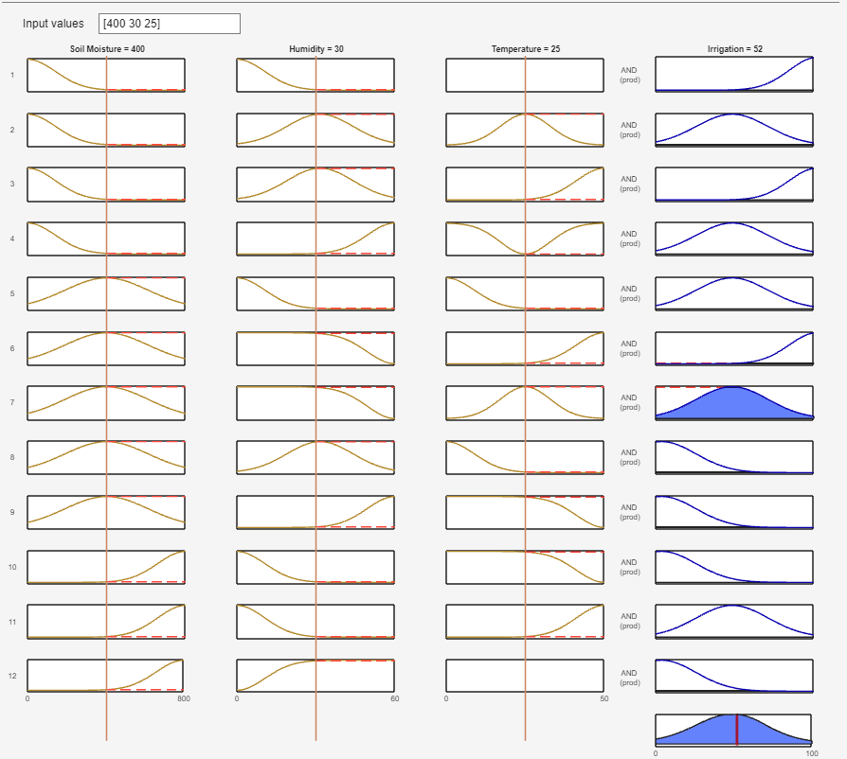

### 4.2 Explanation for the Result Obtained in Appendix 4.1

|  |  |  |  |  |  |
| --- | --- | --- | --- | --- | --- |
| **Explanation of the result** | | | | | |
|  | **INPUTS** | | | **OUTPUT** | **Analysis of rules which could be used to get the result based on logic and relationships defined between inputs and output.** |
|  | **Soil Moisture (0 - 800 bars)** | **Humidity (0 - 60 g/m3)** | **Temperature (0 to 50 0C)** | **Irrigation Output (Based on OPTIMIZED FIS)** |
| 1 | 0 | 0 | 0 | **100** | Rule 1 is Valid |
| 2 | 96 | 5 | 28 | **67** | Rule 2 is Valid |
| 3 | 135 | 6 | 3 | **82** | Rule 1 is Valid |
| 4 | 152 | 11 | 1 | **76** | Rule 4 is Valid |
| 5 | 198 | 55 | 44 | **59** | Rule 4 is Valid |
| 6 | 246 | 26 | 7 | **29** | **RULE NOT FOUND** |
| 7 | 276 | 10 | 17 | **64** | Rule 5 is Valid |
| 8 | 282 | 18 | 12 | **43** | Rule 5 is Valid |
| 9 | 297 | 7 | 27 | **61** | Rule 7 is Valid |
| 10 | 299 | 7 | 33 | **73** | Rule 6 is Valid |
| 11 | 317 | 49 | 8 | **27** | Rule 9 is Valid |
| 12 | 407 | 51 | 44 | **73** | Rule 6 is Valid |
| 13 | 445 | 54 | 35 | **24** | **RULE NOT FOUND** |
| 14 | 493 | 14 | 42 | **85** | Rule 6 is Valid |
| 15 | 503 | 33 | 21 | **49** | Rule 7 is Valid |
| 16 | 531 | 12 | 27 | **52** | Rule 7 is Valid |
| 17 | 535 | 59 | 14 | **17** | Rule 9 is Valid |
| 18 | 548 | 37 | 6 | **27** | Rule 10 is Valid |
| 19 | 550 | 28 | 43 | **84** | **RULE NOT FOUND** |
| 20 | 553 | 5 | 6 | **42** | Rule 11 is Valid |
| 21 | 559 | 32 | 27 | **40** | Rule 12 is Valid |
| 22 | 589 | 60 | 25 | **23** | Rule 12 is Valid |
| 23 | 591 | 45 | 49 | **79** | Rule 11 is Valid |
| 24 | 641 | 42 | 9 | **28** | Rule 12 is Valid |
| 25 | 682 | 5 | 17 | **24** | Rule 10 is Valid |
| 26 | 688 | 9 | 50 | **77** | Rule 11 is Valid |
| 27 | 718 | 52 | 12 | **16** | Rule 12 is Valid |
| 28 | 724 | 1 | 49 | **61** | Rule 10 is Valid |
| 29 | 734 | 24 | 36 | **17** | Rule 10 is Valid |
| 30 | 750 | 17 | 2 | **22** | Rule 12 is Valid |
| 31 | 800 | 60 | 30 | **4** | Rule 12 is Valid |
| 32 | 800 | 60 | 0 | **4** | Rule 12 is Valid |